For Immediate Release: December 1, 2017
Contact: Paul Masters, mastersforrepresentative@gmail.com
(Images available upon request)

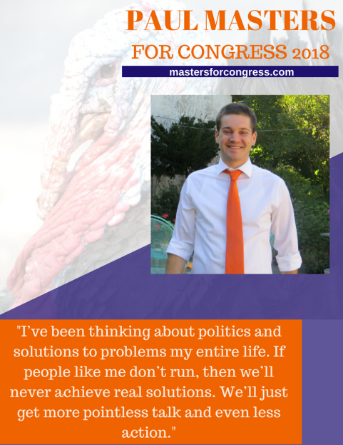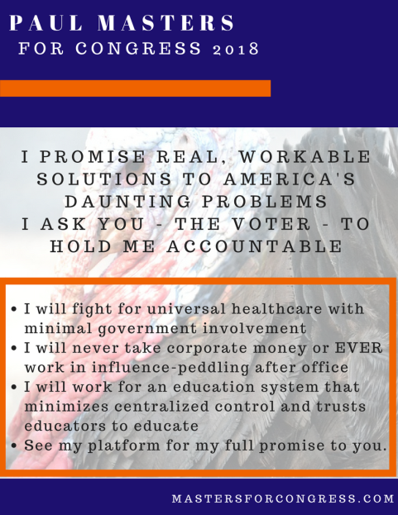

Political Nobody Challenges Republican Incumbent for PA’s 6th District Congressional Seat
Dissatisfied with Current Crop of Candidates, Chester County Resident Seeks to Become One
For more info: mastersforcongress.com

Paoli, PA – (December, 2017) Chester County native Paul Masters hadn’t planned for a career in politics.
After studying economics at the University of Pittsburgh, Paul earned a commission in the US Navy. After five years, Paul decided he'd been away from Pennsylvania for long enough, and decided to leave the service and move back home near his family.
Back home, he met the girl of his dreams, bought a house - and began
to notice that all was not well. Just in his family, his dad (56) who had been a software engineer for 20 years had been reduced to working short-term contracts which eventually dried-up. Unable to work in his field or get health insurance, he started
entry-level at UPS packing trucks. His girlfriend lost her new job after a series of injuries that left her in physical therapy for months, and she too faced the prospect of unsteady paychecks and an utter inability to obtain health insurance. The country was erupting in partisan politics that were as vicious as they were lacking in substance - in which representatives promised change - but suspiciously omitted how, why, or when.
The solution to all of it was simple. Or so it seemed to Masters.
The political process to choose representatives needed to be reoriented to a different set of values, values more likely to lead to the election of candidates capable of achieving results and faced with an incentive to do so – loss of a chance for reelection.
Faced with Representatives in both parties who were seemingly more concerned with winning congressional majorities and partisan bickering than they were with representing voters, and spending campaigns courting donors rather than developing and articulating platforms addressing what they might do in the halls of Congress, he realized that a new style of candidate had to be found. The easiest way to find one, however, was to become one.
"Voters have been promised all sorts of important things for decades, from fiscal sanity to reasonable immigration rules to a less terrible healthcare regime - and none of it has happened," Paul Masters remarked. "We can send politicians to Washington whose intentions are known, who have a clear purpose and mandate, and who can be replaced if they don't get the job done. As it stands, big donors and voters want mutually exclusive things, and it seems clear which side both Party establishments are on."
Since the decision to run for United States Congress against the Republican incumbent in the 6th district – a long-to-impossible shot – he’s been building a grassroots campaign with the assistance of his girlfriend (now Campaign Manager), Erica Minutella, and the support of family, friends, and others looking for a different type of representative in Congress.
"Everything has been built with the smallest amount of funds possible," Masters explained. "President Trump and Bernie Sanders proved that direct communication with voters is a viable political strategy, and I will focus on promoting my ideas and way of thinking about problems rather than play the money game." The campaign website
was created on a free website hosting platform. Promotional efforts have revolved around organic social media and word-of-mouth efforts. Feedback is always welcome and solicited.
His platform can be found on the website mastersforcongress.com. His goal is to find workable solutions to problems. Solutions that favor smaller, well-proscribed government roles and also represent a rough estimate of what a compromise position between the two parties could look like. Issues covered on the platform include:
- Healthcare
- Immigration
- Education
- Budget and Tax Reform
- Term Limits and Money in Politics
- Energy/Environment
- Trade and Foreign Policy
Throughout his candidacy, he will be fully accessible to voters of either party, and candidates of either party. He can be reached via the website, mastersforcongress.com, on social media through Facebook (facebook.com/MastersForCongress/) and Twitter (twitter.com/MastersForRep), and through a series of planned Facebook live streams, Sundays at 2 pm, and local events (most likely hosted at his own home: see website for the upcoming schedule).
While donations are welcome, Masters has pledged to neither seek nor accept any form of funding other than direct donations within the applicable limits, and to never endorse nor encourage the operations of any Super PAC (or similarly funded political spending vehicle) for any reason.
The primary election date for the 6th District is May 15, 2018. The incumbent candidate for the Republican Party is Representative Ryan Costello.
About Paul Masters:
Paul Masters grew up in the 6th District in the West Chester/Exton area. After high school, he attended the University of Pittsburgh, graduating in 2010, whereafter he went to Navy Officer Candidate School and served for five years as an officer on destroyers. He remains an active reservist After resigning his commission, he moved back home and now lives in Paoli, PA.
Party: Republican
Press Contact
Erica Minutella
ejminutella@gmail.com

